INDUSTRIAL SURVEYING

3

3

3

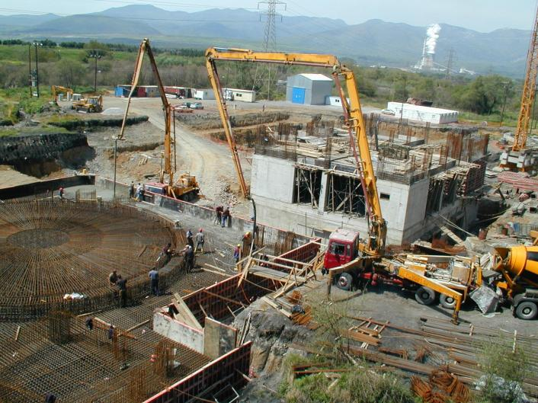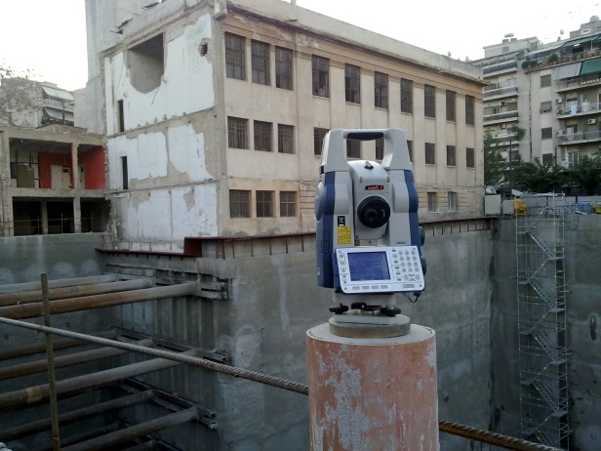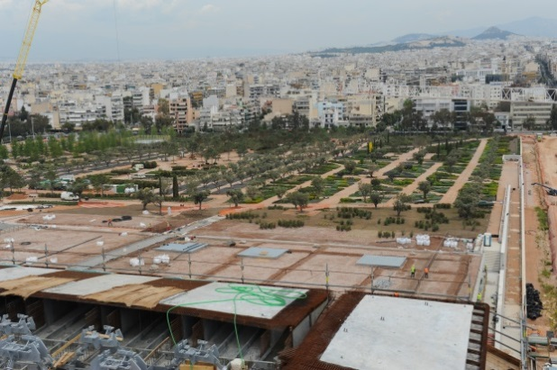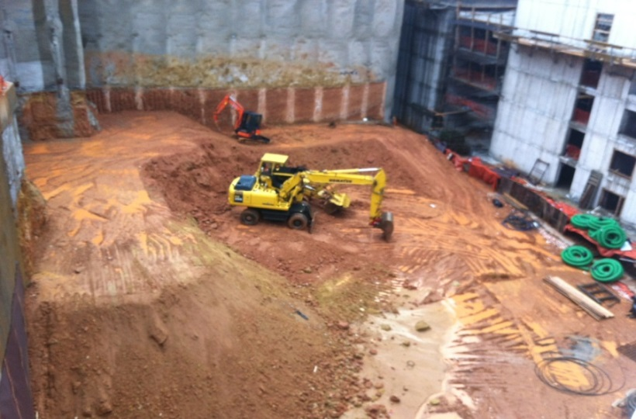

WFGD Unit at Unit III of PPC S.A Megalopolis

Karouzos Station Shopping Center, Attica

Hill Area at SNFCC.

* Karouzos Shopping Center at Larisis Train Station, Attica. Deformation monitoring on piles and on adjustment and structures buildings during earthworks periods.
* New Office Complex Building of Anangel Shipping Company, Kallithea, Attica. Deformation monitoring on piles and on adjustment and structures buildings during earthworks periods.
* 6-floor Underground Parking Building, Kifisia, Attica. Deformation monitoring on piles and on adjustment and structures buildings during earthworks periods.
* Rea Maternity Hospital, Piraeus, Attica.
* ”Gold line Underground”, Doha, Qatar. Monitoring constructing buildings inside.
* Building Monitoring of Public Store, Syntagma, Athens. Monitoring on column & bims.
* Tsakona Bridge, Kalamata. Deformation monitoring on bridges temporary support frames.
* WFGD UNIT at UNIT III of PPC S. A, Megalopolis
* Real time deformation monitoring on tanks surface during hydrotest period.
* Structural monitoring on structures and building across the projects site.
* Stavros Niarchos Foundation Cultural Center (SNFCC), Kalithea
* Deformation monitoring on structures and adjustments building around the site.
* Deformation monitoring and landslide examination on structures during earthworks period.
* Automated Monitoring System (AMS) installation – deformation monitoring on support frames during casting.
* AMS installation – deformation monitoring on Canopy’s period during depropping and uplift period.

Opera Auditorium at SNFCC

Underground Parking, Kifisia, Attica.

PROJECTS

4

DEFORMATION MONITORING

Surveying Precision





3

High Pressure Natural Gas and Regulating Station, Tema, Ghana

3

3

INDUSTRIAL SURVEYING

INDUSTRIAL SURVEYING

3

****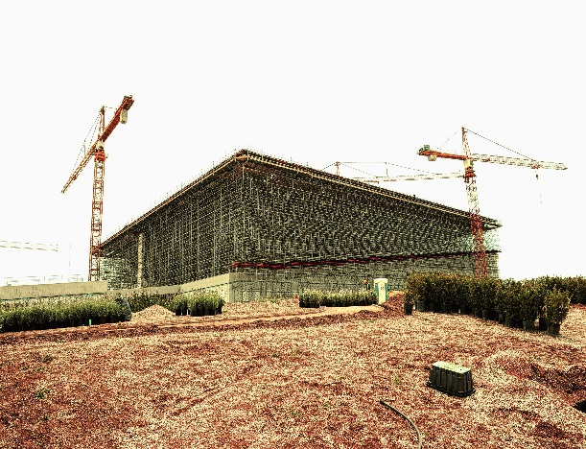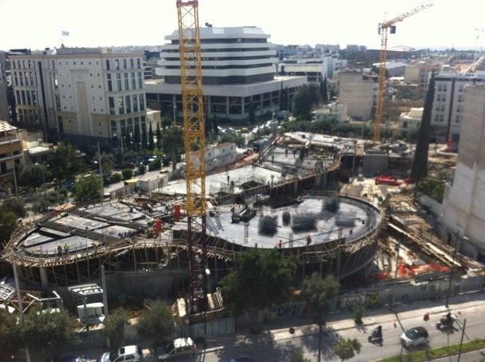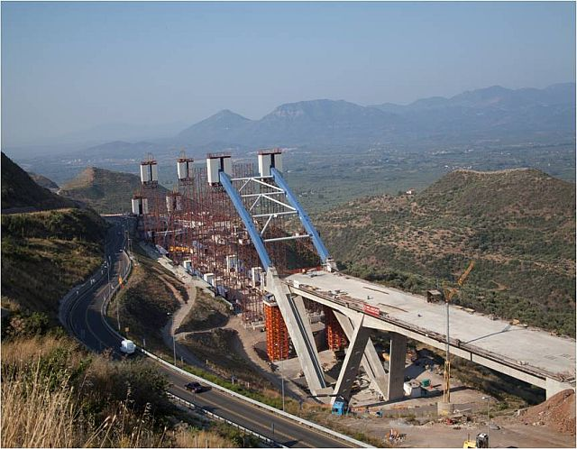

Stavros Niarchos Founadtion Cultural Center

Office Complex Building of Anangel , Kallithea, Attica.

Tsakona Bridge, Kalamata

Public Store, Syntagma, Attica

3

AKSM implements an istrumentetion and monitoring system (MYSYS) that meets all the requirements specified by design. For each section of the works in a project, proposals are submitted for the setup of the geodetical monitoring system to the Client.

**1. LEVELLING MEASUREMENTS**

1. Buildings - structures

Levelling measurements are taken on levelling pins installed at the ground surface (road surface, sidewalks, etc.) or on buildings and / or on deeply embedded rods.

The levelling pins on a surface or on buildings (e.g. vertical features, columns and walls) are of the embedment screw type of galvanized steel. Alternatively, where drilling and embedment is impossible, levelling contact pins are used with an aluminium plate or corner and a steel ball suitably adhered to a hemispherical hole of same diameter.

The measurements of the levelling points are cared out with a precision of at least ± 1mm per kilometer and always with open levelling routings, completely dependent from their two ends on the levelling starting points (benchmarks) with known elevation. The measurements instruments and their accessories (remote distance measurement devices, tripods, etc.) are serviced, checked according to the instructions of the manufacturer and will be replaced when it is necessary.

1. Ground surface above tunnels

Sections and grid of pins according to the monitoring design plan are istalled. The distance between the pins of each section is subject to the design study. On the road pavements, the layout varies depending on the actual conditions.

1. Influence zone free field (in all other cases except the above)

Pins are developed on a grid covering the entire influence zone. Pins that cannot be installed (e.g. in streets with heavy traffic) can be pleased and measured at any other location further to pertinent communication with Client.

DEFORMATION MONITORING

The deformation monitoring of a land or construction represents a systematic action of observation, measurement and analysis of the way they respond to influence of surrounding agents, taking permanently in consideration the projection parameters of functionality, stability and safety.

For a proper monitoring of construction behavior in time constructions that are subjects to experimental solicitation obtaining observations in a relative short time in highly required.

**METHODOLOGY**

DEFORMATION MONITORING

www.aksm.gr